December 2016
Sunday | Monday | Tuesday | Wednesday | Thursday | Friday |  |  | Saturday
4 | 5 | 6 | 7 | 8 |  | 9 | 10
 |  | Fa La La La La | Fun with | Holiday Wear!
11 | 12 | 13 | 14 | 15 |  | 16  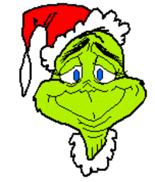  Grinch Day! Wear Green! | 17
 |  | Wear Red Day!! |  | Holiday Headgear!
18 | 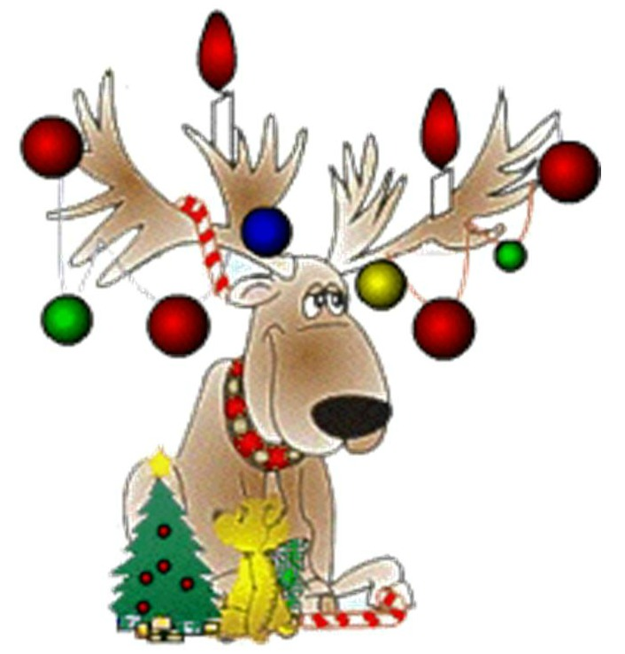  19  Sparkly Holiday Wear! | 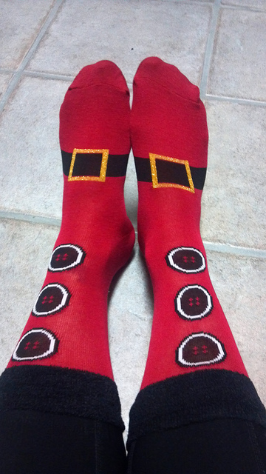  20  Holiday Foot wear!  Holiday socks and/ or shoes! | 21  Comfy Flannel Day!  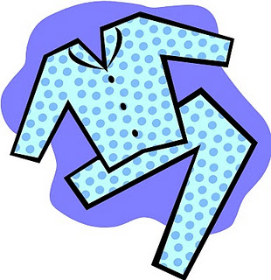  PJ’s or Flannel shirts! | 22  Happy Holidays! |  | 23  Happy Holidays! | 24  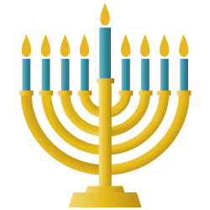  Hanukkah and Christmas about to begin  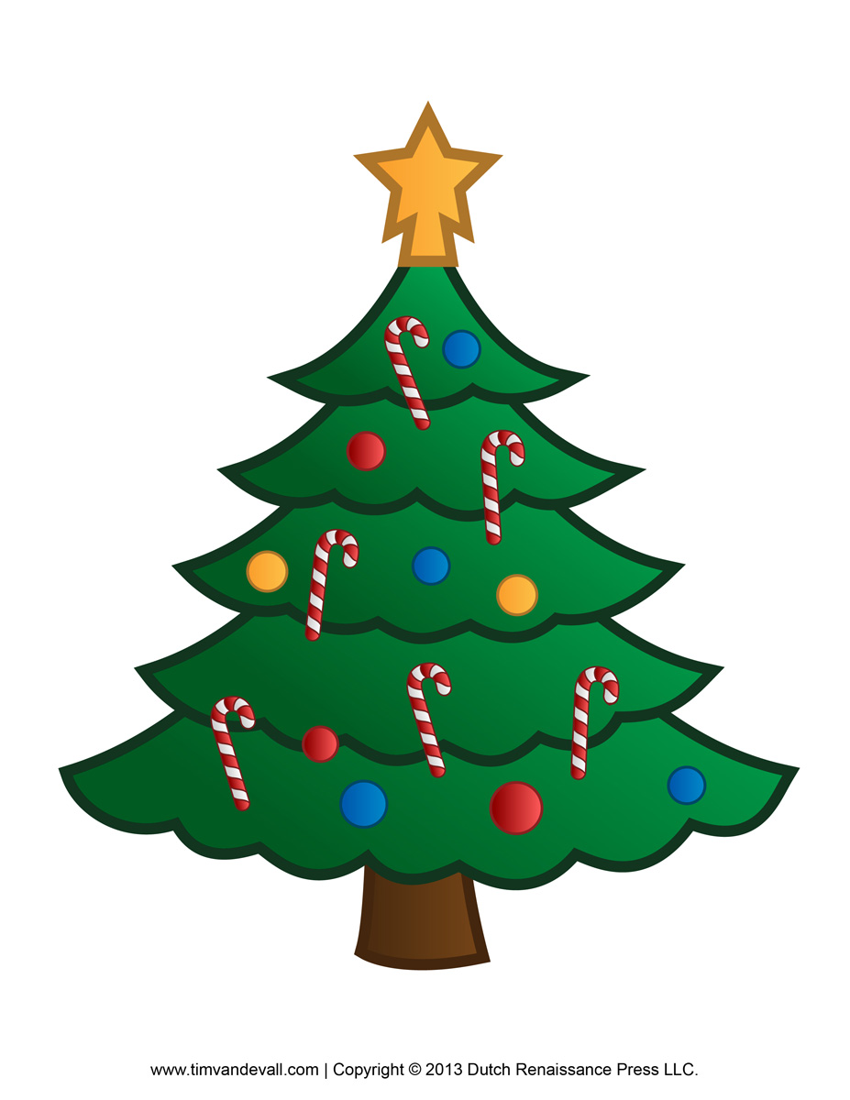

Holiday Fun at Addison begins on Dec. 13th. Your child is welcome to participate by wearing the above winter fun wear!

